Climate Change
Case Study: India

CLIMATE CHANGE IN INDIA
Look at the map. Think about the physical geography of India, such as coasts, rivers, and mountains, when answering the questions on this worksheet.
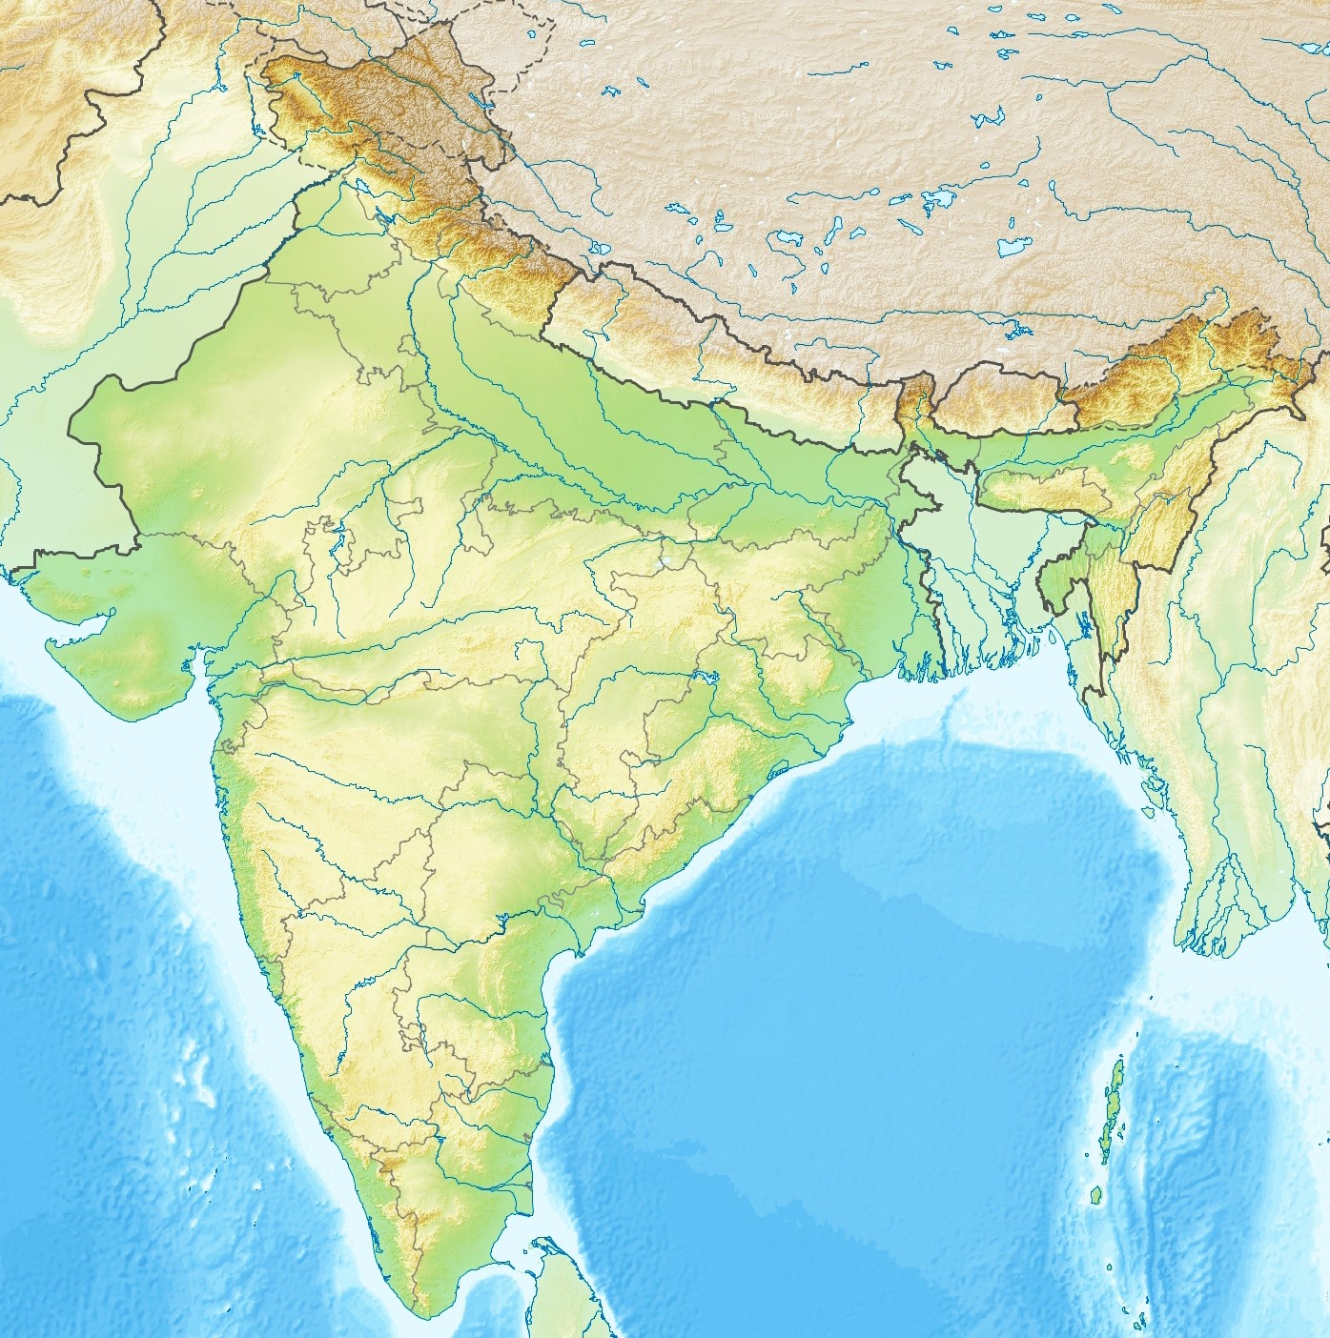
Topographic map of India. Credit: Wikimedia.

EXTREME WEATHER IN COLONIAL INDIA
Look at the picture below which appeared in a British newspaper in 1864. It shows the day after a large cyclone in Calcutta, British India.
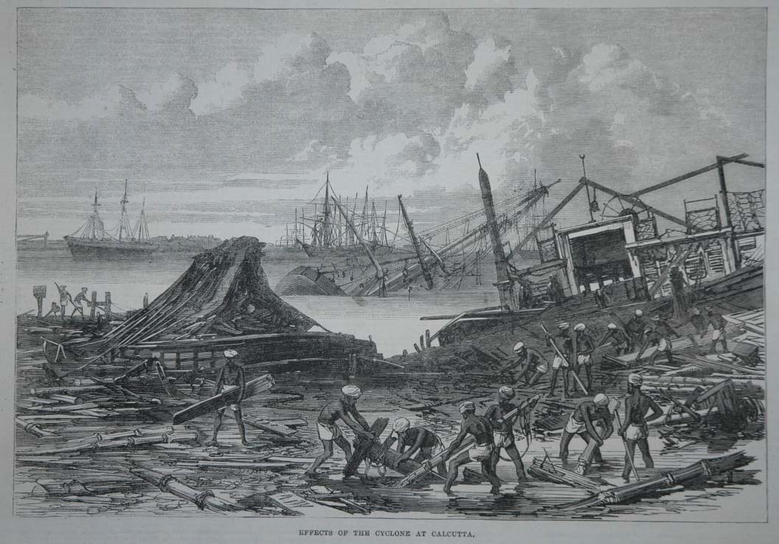
“Effects of the Cyclone at Calcutta”, Illustrated London News (1864). Credit: Public Domain.
Identify examples of the following types of impact of the storm.
Social | Economic | Political | Environmental

FLOODS IN COLONIAL INDIA
Look at the picture below which appeared in a British newspaper in 1856. It shows the flooding of the River Ganges in British India.
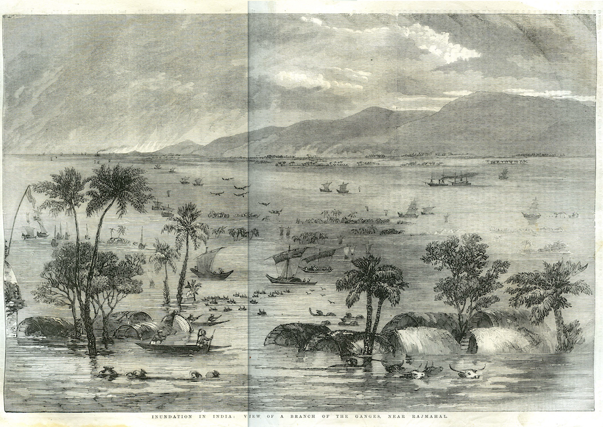
“Inundation in India”, Illustrated London News (1856). Credit: Public Domain.
What do you think the effects of the 1856 flood might have been? Distinguish between short-term and long-term effects.
Short-Term Effects | Long-Term Effects

NATURAL AND HUMAN FACTORS OF FLOODING
Complete the following table of natural and human factors behind flooding and flood damage in colonial India.
Natural Factors | Human Factors

ASSESSING THE IMPACT OF EMPIRE on FLOODS AND EXTREME WEATHER
What difference, if any, did the British Empire make to the causes and effects of floods and extreme weather in colonial India?
………………………………………………………………………………………………………………………….………………………………………………………………………………………………………………………….………………………………………………………………………………………………………………………….………………………………………………………………………………………………………………………….………………………………………………………………………………………………………………………….

MITIGATING CLIMATE CHANGE IN POSTCOLONIAL INDIA
Anna Mani studied the effects of solar radiation on the atmosphere and weather.
How might this information help mitigate the risk of climate change in India?
………………………………………………………………………………………………………………………….………………………………………………………………………………………………………………………….………………………………………………………………………………………………………………………….

MITIGATING CLIMATE CHANGE IN POSTCOLONIAL INDIA
B. N. Goswami developed an accurate climate model of the rainfall in the monsoon season.
How might this information help mitigate the risk of climate change in India?
………………………………………………………………………………………………………………………….………………………………………………………………………………………………………………………….………………………………………………………………………………………………………………………….

ADAPTING TO CLIMATE CHANGE IN POSTCOLONIAL INDIA
How might India adapt to ongoing climate change?
………………………………………………………………………………………………………………………….………………………………………………………………………………………………………………………….………………………………………………………………………………………………………………………….
How do you think geographers can help with this challenge?
………………………………………………………………………………………………………………………….………………………………………………………………………………………………………………………….………………………………………………………………………………………………………………………….

ANNA MANI INTERVIEW
Read the following extracts from an interview with Dr Anna Mani, conducted in 1991 for the World Meteorological Organization. Then answer the questions below. For the full version of the interview, see: Hessam Taba, “Miss Anna Mani,” WMO Bulletin, 1991 (40)
Taba: What were the circumstances that led you to… turn to meteorology?
Mani: It was entirely by accident. The Second World War had just ended. Like most Indians I was for Mahatma Gandhi and freedom for India, so that my feelings were then anything but pro-British. Therefore when the Government offered scholarships for study in the United Kingdom and the USA my first reaction was one of rejection. However, a colleague at the Institute managed to persuade me to apply, pointing out that it was our money (the sterling balances) that was being spent on the scholarships and I might as well get something out of it. So I applied and went for an interview in New Delhi. No scholarships were available in my chosen field of physics, but there was apparently a need for expertise in the domain of meteorological instrumentation. So I agreed to go to the United Kingdom in order to learn something about this. It was thus not entirely of my own choice that I came into meteorology, but I shall always be grateful that things turned out as they did.
Taba: Your country has long been among the leaders in the measurement of atmospheric ozone.
Mani: Until fairly recently, most Meteorological Services took little or no interest in ozone since it had nothing to do with forecasting the weather. Professor Ramanathan bridged the gap most effectively between the national Meteorological Services and non-governmental bodies… In 1964 Professor Ramanathan handed over the Indian network of Dobson spectrophotometer stations to the Meteorological Department, and that was when I started being involved in the programme. At Pune, my colleague Dr C. R. Sreedharan developed an electrochemical ozone sonde. We took regular ozone soundings from three stations in India. In the meantime I had taken over as Deputy Director General (Instruments) at New Delhi. After our ozone spectrophotometers had been modernized to incorporate up-to-date electronics in the 1970s and gave highly reliable results, we worked back through the earlier observations applying a correction factor to make the whole series of data comparable. I have recently been involved in analysing ozone data from Indian stations for the period 1960 to 1990 and have found no apparent decrease in total ozone in the tropics during the past 30 years. Now that we have ozone sensors aboard orbiting satellites we have the advantage of global coverage by one single instrument which gives a good relative distribution of total ozone, but it remains essential to have a network of good observing stations on the ground so that we have an idea of the absolute values, or 'ground truth'.
Taba: You have also been researching wind data for the purpose of harnessing energy I believe?
Mani: This is currently my main interest and responsibility. At the request of the newly-established Department of Non-Conventional Energy Sources, all the available wind data from the IMD stations were published in a third volume, Wind Energy Data for India (1983). Realizing that the meteorological observatories did not give a correct picture of the country's wind-energy potential, we have since (at the request of the Department of Non-Conventional Energy Sources) organized wind measurements at over 600 sites using 20- and 5-metre instrumented masts. The Indian Institute of Tropical Meteorology at Pune has established a field research unit at Bangalore to look after this extensive national programme. Recently we published Wind Energy Resource Survey in India that presents three years' accumulated data from 21 sites equipped with 20-metre masts (sensors at 10 and 20 m). Our major tasks at present are to help in identifying potential sites throughout the country for wind farms for the large-scale generation of electric power and to compile a wind climatology.
Taba: How do you feel about meteorology today in India and elsewhere?
Mani: We still have a long way to go—particularly in forecasting the monsoon—despite more than a hundred years of concentrated effort. I still place measurements first. Neither models nor supercomputers can give reliable short- and medium-range forecasts unless their input of observed data (especially for the upper air) is reliable. I would also like to see better education and training in meteorology—the universities should be leading in this, but at present they are not. I am currently involved in the publication of a series of textbooks by Indian meteorologists which should, one hopes, fill the lacunae that exist in books on Indian weather and climate.

QUESTIONS
Why did Anna Mani become a meteorologist?
………………………………………………………………………………………………………………………….………………………………………………………………………………………………………………………….………………………………………………………………………………………………………………………….………………………………………………………………………………………………………………………….
What scientific techniques and instruments did Mani and her colleagues use to study the climate?
………………………………………………………………………………………………………………………….………………………………………………………………………………………………………………………….………………………………………………………………………………………………………………………….………………………………………………………………………………………………………………………….

What challenges for the future of climate science does Mani identify?
………………………………………………………………………………………………………………………….………………………………………………………………………………………………………………………….………………………………………………………………………………………………………………………….………………………………………………………………………………………………………………………….

