Climate Change
Case Study: India

CLIMATE CHANGE IN INDIA
Look at the map. Think about the physical geography of India, such as coasts, rivers, and mountains.
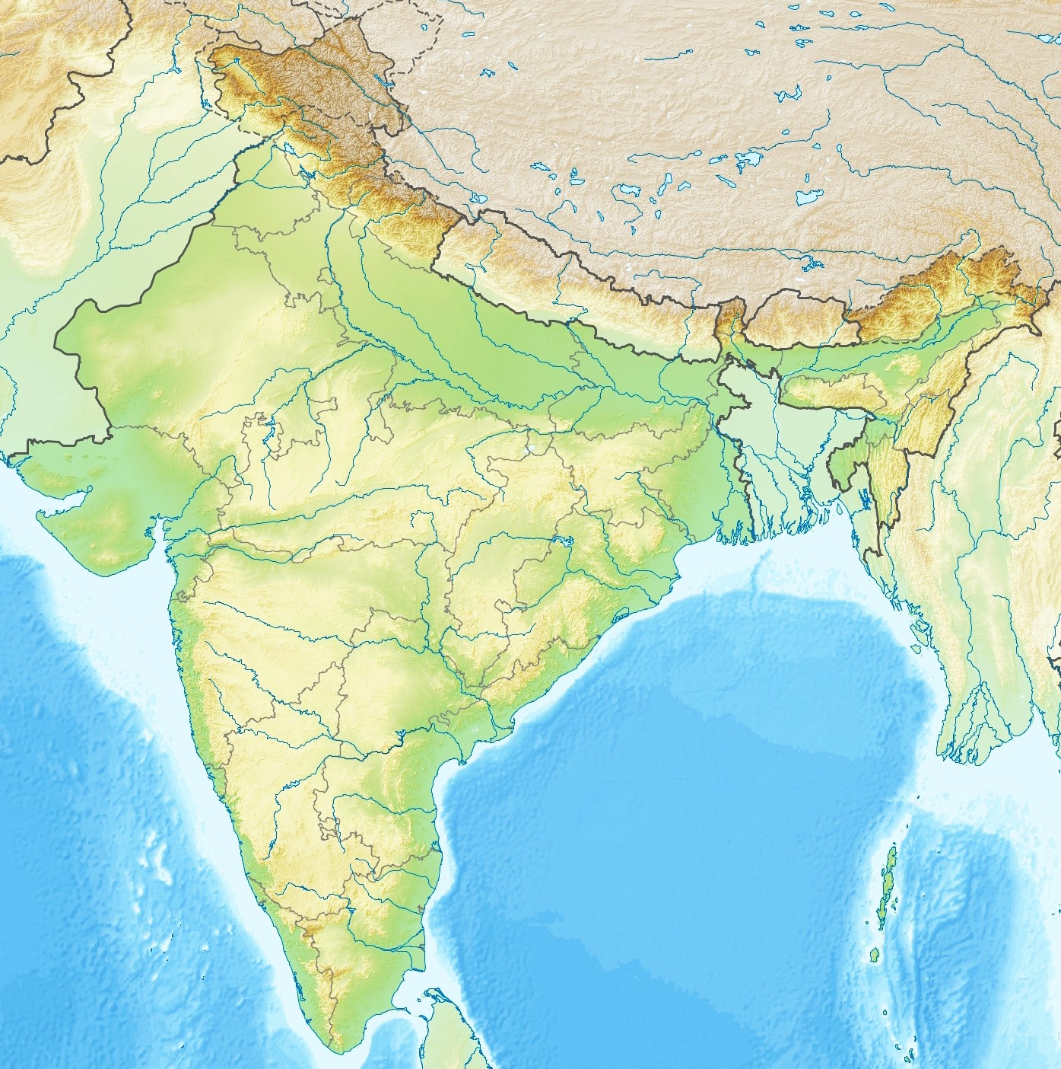
Topographic map of India. Credit: Wikimedia.

List five possible effects of climate change in India today.
- …………………………………………………………………………………………
- …………………………………………………………………………………………
- …………………………………………………………………………………………
- …………………………………………………………………………………………
- …………………………………………………………………………………………

EXTREME WEATHER IN COLONIAL INDIA
Look at the picture below which appeared in a British newspaper in 1864. It shows the day after a large cyclone in Calcutta, British India.
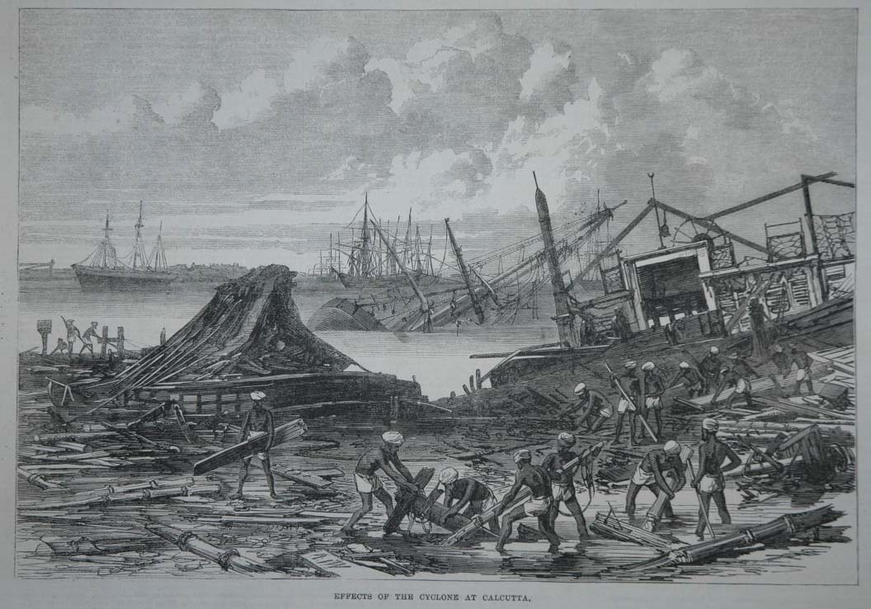
“Effects of the Cyclone at Calcutta”, Illustrated London News (1864). Credit: Public Domain.
Why do you think there are only Indian workers clearing the damage?
………………………………………………………………………………………………………………………………………………………………………………………………………………………………………………………………………………………………………………………………………………………………………………

FLOODS IN COLONIAL INDIA
Look at the picture below which appeared in a British newspaper in 1856. It shows the flooding of the River Ganges in British India.
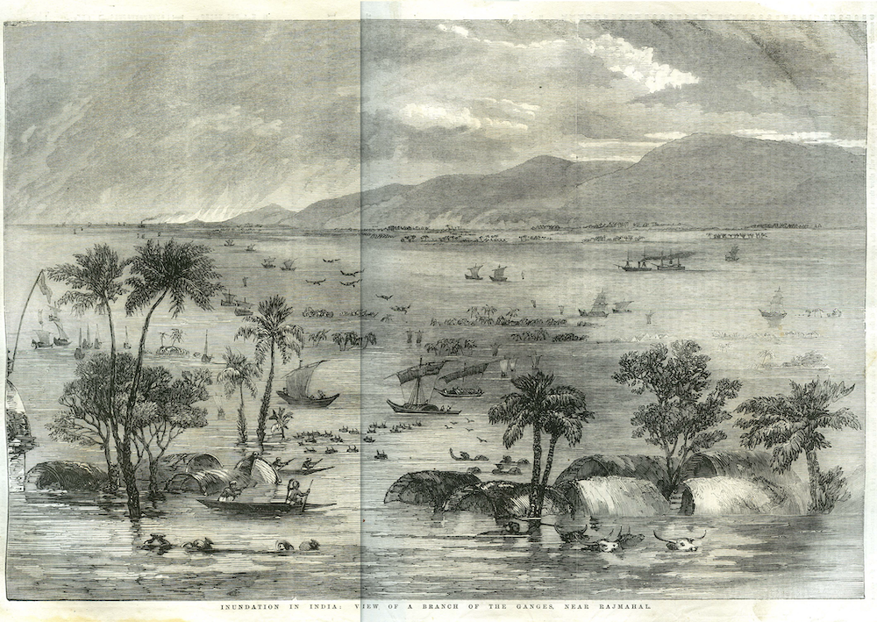
“Inundation in India”, Illustrated London News (1856). Credit: Public Domain.
What do you think the effects of the 1856 flood might have been? Distinguish between short-term and long-term effects.
Short-Term Effects | Long-Term Effects

NATURAL AND HUMAN FACTORS OF FLOODING
Complete the following table of natural and human factors behind flooding and flood damage in colonial India.
Natural Factors | Human Factors

ASSESSING THE IMPACT OF EMPIRE on FLOODS AND EXTREME WEATHER
What difference, if any, did the British Empire make to the causes and effects of floods and extreme weather in colonial India?
………………………………………………………………………………………………………………………….………………………………………………………………………………………………………………………….………………………………………………………………………………………………………………………….………………………………………………………………………………………………………………………….………………………………………………………………………………………………………………………….

MITIGATING CLIMATE CHANGE IN POSTCOLONIAL INDIA
Anna Mani studied the effects of solar radiation on the atmosphere and weather.
How might this information help mitigate the risk of climate change in India?
………………………………………………………………………………………………………………………….………………………………………………………………………………………………………………………….………………………………………………………………………………………………………………………….
B. N. Goswami developed an accurate climate model of the rainfall in the monsoon season.
How might this information help mitigate the risk of climate change in India?
………………………………………………………………………………………………………………………….………………………………………………………………………………………………………………………….………………………………………………………………………………………………………………………….

ADAPTING TO CLIMATE CHANGE IN POSTCOLONIAL INDIA
How might India adapt to ongoing climate change?
………………………………………………………………………………………………………………………….………………………………………………………………………………………………………………………….………………………………………………………………………………………………………………………….
How do you think geographers can help with this challenge?
………………………………………………………………………………………………………………………….………………………………………………………………………………………………………………………….………………………………………………………………………………………………………………………….

