Natural Hazards
Case Study: Pakistan

tectonic plates
Examine the following map of Pakistan, Afghanistan, and India. The blue line represents the division between the Eurasian and Indian tectonic plates.
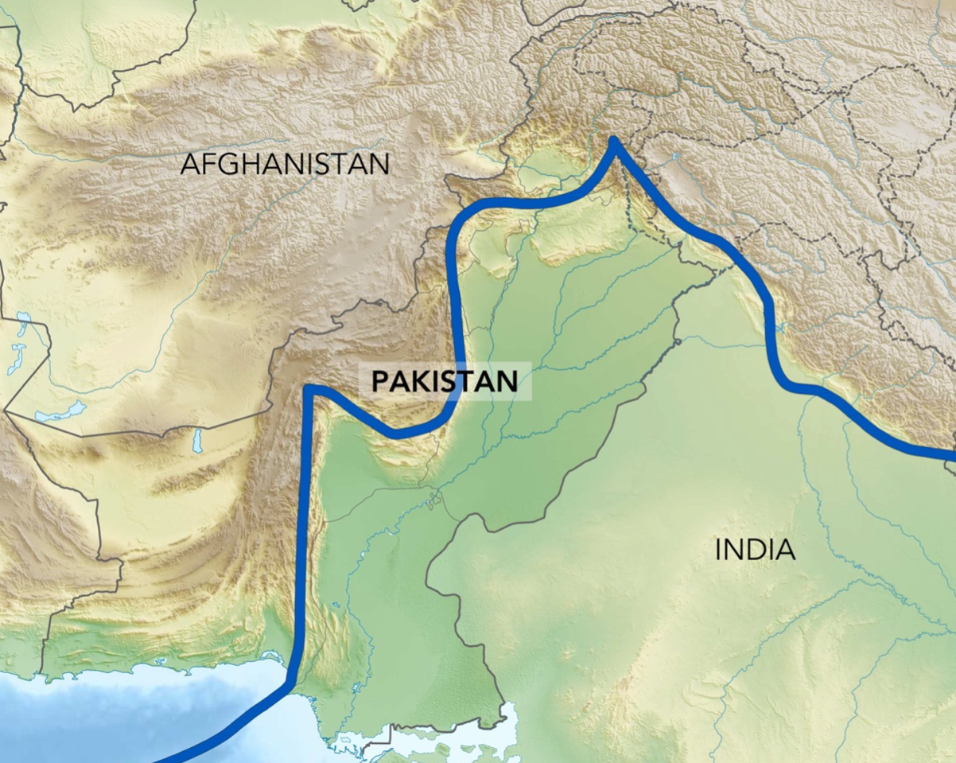
Topographic map of Eurasian and Indian plates. Credit: Wikimedia.
Why are there so many earthquakes in Pakistan? Use the concept of plate tectonics in your answer.
…………………………………………………………………………………………………………………………..………………………………………………………………………………………………………………………….………………………………………………………………………………………………………………………….…………………………………………………………………………………………………………………………

PHOTOGRAPHS OF 1935 QUETTA EARTHQUAKE
Look at the following photographs taken before and after the 1935 Quetta earthquake.
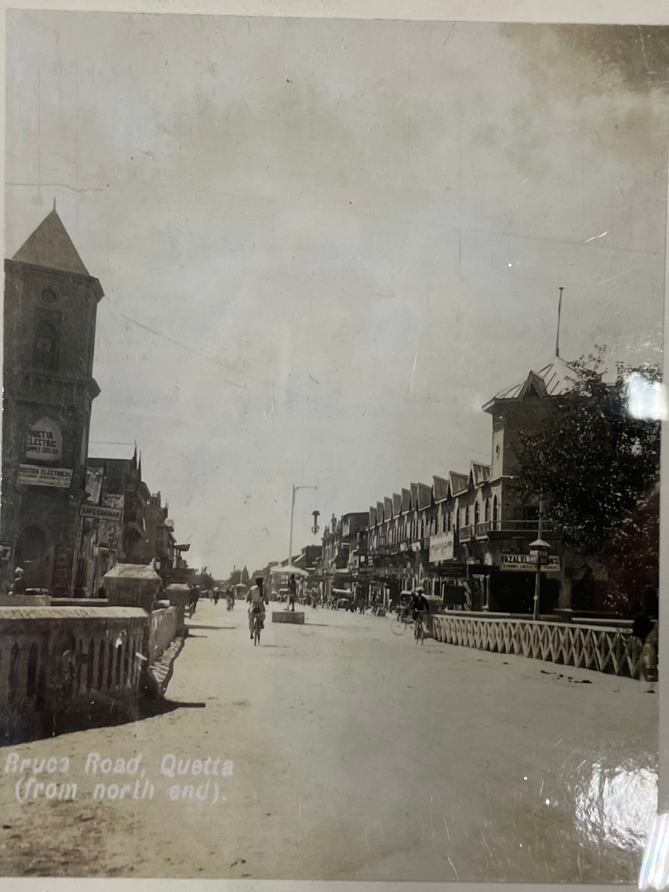
Photograph of Bruce Road, Quetta, British India (Pakistan) taken before the 1935 earthquake. Credit: T. R. J. Ward / Royal Geographical Society.
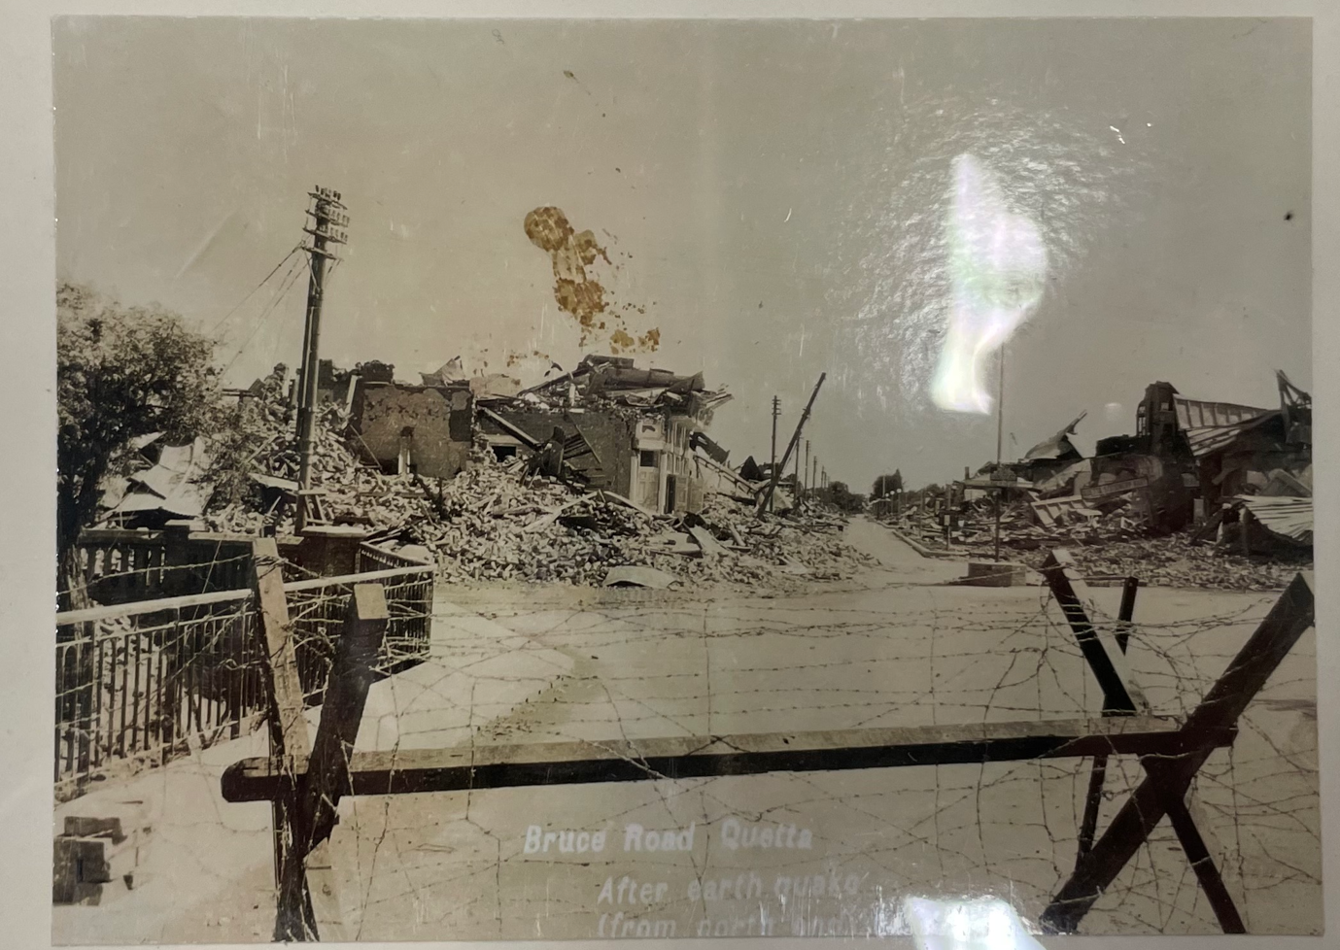
Photograph of Bruce Road, Quetta, British India (Pakistan) taken after the 1935 earthquake. Credit: T. R. J. Ward / Royal Geographical Society.

EFFECTS AND CONSEQUENCES OF 1935 QUETTA EARTHQUAKE
What were the primary effects of the earthquake?
………………………………………………………………………………………………………………………….………………………………………………………………………………………………………………………….
What were the secondary effects of the earthquake?
………………………………………………………………………………………………………………………….………………………………………………………………………………………………………………………….
What were the social effects of the earthquake?
………………………………………………………………………………………………………………………….………………………………………………………………………………………………………………………….
What were the economic effects of the earthquake?
………………………………………………………………………………………………………………………….………………………………………………………………………………………………………………………….
What were the environmental effects of the earthquake?
………………………………………………………………………………………………………………………….………………………………………………………………………………………………………………………….

IMMEDIATE AND LONG-TERM RESPONSES TO 1935 QUETTA EARTHQUAKE
Fill in the following table of short- and long-term responses to the 1935 Quetta earthquake:
Short-Term Responses | Long-Term Responses

ASSESSING THE IMPACT OF EMPIRE on EARTHQUAKES
What difference, if any, did the British Empire make to the effects and responses to the 1935 Quetta earthquake?
………………………………………………………………………………………………………………………….………………………………………………………………………………………………………………………….………………………………………………………………………………………………………………………….………………………………………………………………………………………………………………………….………………………………………………………………………………………………………………………….

MEASURING THE 1935 QUETTA EARTHQUAKE
Examine the following table which was printed in the Records of the Geological Society of India in 1935. The table shows the time of the arrival of the main aftershock from the Quetta earthquake at different locations around the world.
Focus on the columns underlined in red.
- Station is the location of the city where the aftershock was recorded.
- P(obs) is the amount of time it took for the P-wave to reach the city (in minutes and seconds).
- S(obs) is the amount of time it took for the S-wave to reach the city (in minutes and seconds).
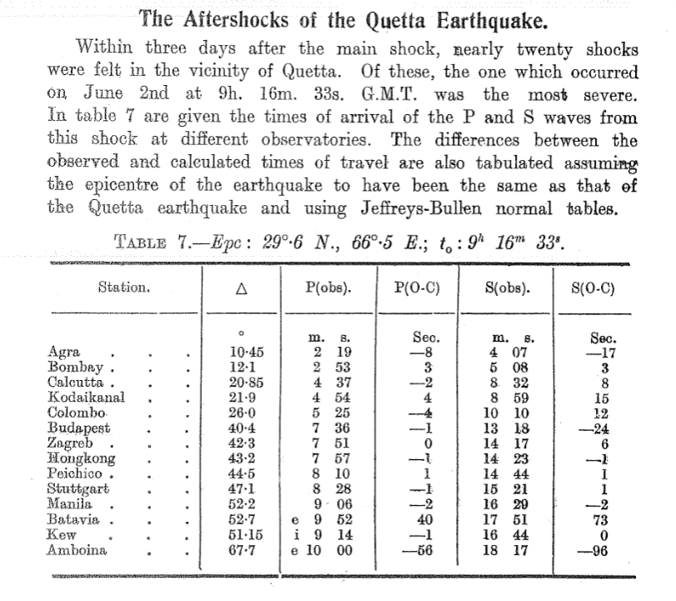

Explain the difference between a P-wave and an S-wave. Use evidence from the table above to support your answer.
………………………………………………………………………………………………………………………….………………………………………………………………………………………………………………………….………………………………………………………………………………………………………………………….………………………………………………………………………………………………………………………….………………………………………………………………………………………………………………………….………………………………………………………………………………………………………………………….………………………………………………………………………………………………………………………….………………………………………………………………………………………………………………………….

MANAGEMENT OF EARTHQUAKE RISK IN PAKISTAN
Why did people continue to live in areas at risk of earthquakes in Pakistan following independence in 1947?
………………………………………………………………………………………………………………………….………………………………………………………………………………………………………………………….………………………………………………………………………………………………………………………….………………………………………………………………………………………………………………………….………………………………………………………………………………………………………………………….
What challenges did Pakistan face managing earthquake risk following independence in 1947?
………………………………………………………………………………………………………………………….………………………………………………………………………………………………………………………….………………………………………………………………………………………………………………………….………………………………………………………………………………………………………………………….………………………………………………………………………………………………………………………….
How did Pakistani geologists and geographers help respond to these challenges and manage risks of earthquakes?
………………………………………………………………………………………………………………………….………………………………………………………………………………………………………………………….………………………………………………………………………………………………………………………….………………………………………………………………………………………………………………………….………………………………………………………………………………………………………………………….

