Hot Deserts
Case Study: Sudan

DESERTIFICATION
Write down the definition of desertification.
……………………………..……………………………..……………………………..……………………………..……………………………..……………………………..……………………………..……………………………..……………………………..……………………………..……………………………..………………………….

EXPANDING DESERTS
The Sahara Desert has expanded by around ………% since 1920. Around ………% of Sudan is at risk of desertification.

MAPPING DESERTIFICATION
Examine the following map which shows vulnerability to desertification. Red indicates areas of very high vulnerability.
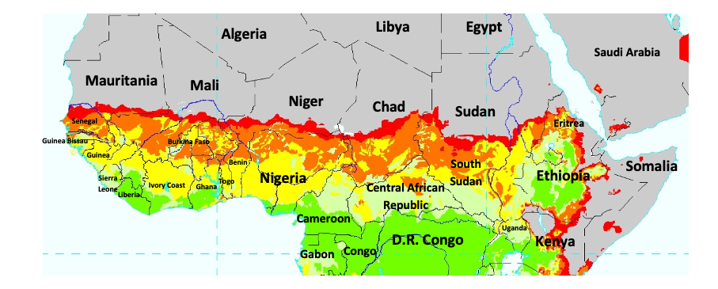
Write down the names of five countries at very high risk of desertification.

- ………………………………………
- ………………………………………
- ………………………………………
- ………………………………………
- ………………………………………

NATURAL AND HUMAN FACTORS
Complete the following table of natural and human factors behind desertification in Sudan.
Natural Factors | Human Factors

SHORT AND LONG-TERM EFFECTS
Complete the following table of short- and long-term effects of desertification in Sudan.
Short-Term Effects | Long-Term Effects

COLONIALISM IN SUDAN
Sudan was colonised by which two countries in 1899?
……………………………………. and …………………………………………………
Sudan gained independence from the British Empire in …………............
South Sudan became independent from Sudan in ……………………

ASSESSING THE IMPACT OF EMPIRE on DESERTIFICATION
What difference, if any, did the British Empire make to the causes and impacts of desertification in Sudan?
………………………………………………………………………………………………………………………….………………………………………………………………………………………………………………………….………………………………………………………………………………………………………………………….………………………………………………………………………………………………………………………….…………………………………………………………………………………………………………………………

AGRICULTURE IN COLONIAL SUDAN
Look at the following poster. It was made by the “Empire Marketing Board” in 1935 and displayed in London. The poster was designed to promote cotton grown in colonial Sudan to the British public.
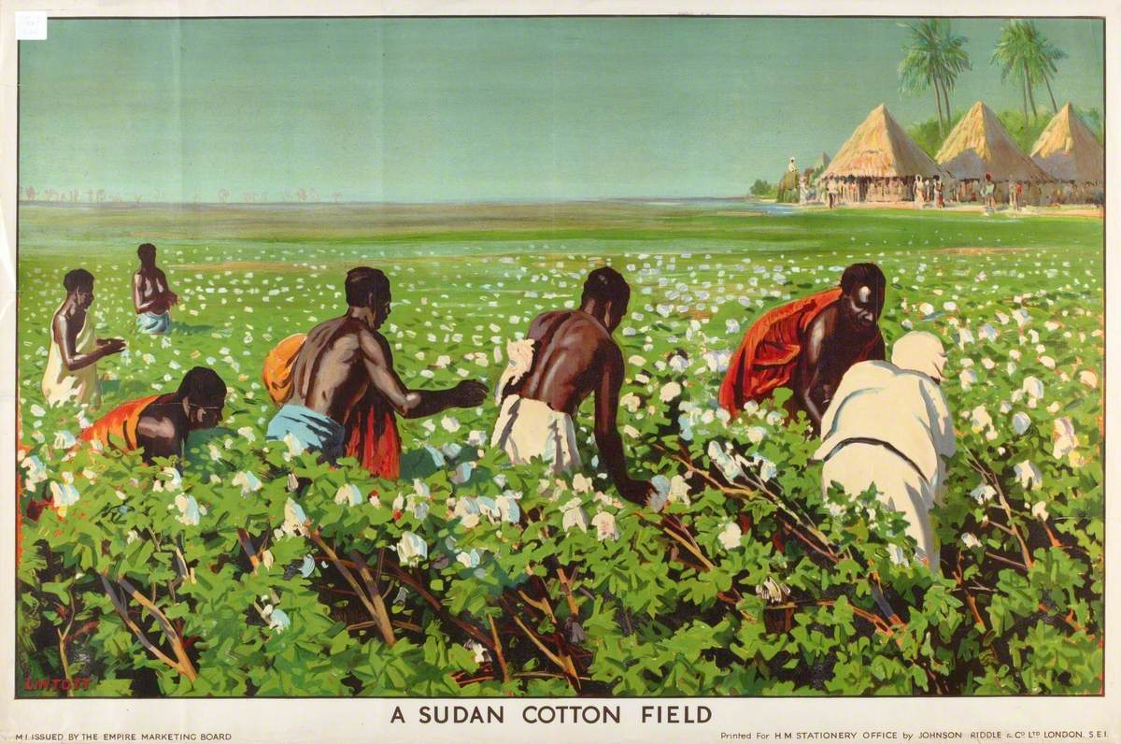
‘A Sudan Cotton Field’, Empire Marketing Board. Credit: Manchester Art Gallery, Art UK.

What aspects of colonialism are visible in the image?
……………………………..……………………………..……………………………..……………………………..……………………………..……………………………..……………………………..……………………………..……………………………..……………………………..……………………………..…………………………...……………………………..……………………………..……………………………..……………………………
How is the environment in Sudan shown in this image?
……………………………..……………………………..……………………………..……………………………..……………………………..……………………………..……………………………..……………………………..……………………………..……………………………..……………………………..…………………………..……………………………..……………………………..……………………………..…………………………….
Do you think this is an accurate image of colonial Sudan? Why? Why not?
……………………………..……………………………..……………………………..……………………………..……………………………..……………………………..……………………………..……………………………..……………………………..……………………………..……………………………..…………………………...……………………………..……………………………..……………………………..……………………………

STUDYING DESERTIFICATION IN POSTCOLONIAL SUDAN
Mohamed Hag Ali Hassan studied the physical forces behind desertification. He helped to create accurate models of the expansion of the desert.
How might this information help manage the risk of desertification in Sudan today?
……………………………..……………………………..……………………………..……………………………..……………………………..……………………………..……………………………..……………………………..……………………………..……………………………..……………………………..…………………………...……………………………..……………………………..……………………………..……………………………
Balgis Osman-Elasha studied the social and economic effects of desertification.
How might this information help manage the risk of desertification in Sudan today?
……………………………..……………………………..……………………………..……………………………..……………………………..……………………………..……………………………..……………………………..……………………………..……………………………..……………………………..…………………………..……………………………..……………………………..……………………………..…………………………….

Balgis Osman-Elasha INTERVIEW
Read the following extracts from an interview with Dr Balgis Osman-Elasha, conducted in 2009 for the United Nations Food and Agriculture Organization. Then answer the questions below. For the full version of the interview, see “Interview: Balgis Osman Elasha”, World Forestry Congress Newsletter (2009).
Q. What is the role played by the forest sector in environmental rehabilitation and management?
Osman Elasha: Forest ecosystems provide a wide range of support, supply, regulatory and cultural services (“ecosystem services”). Climate change could lead to significant changes in the supply of such services, particularly if coupled with population growth, urbanization, deforestation, forest fragmentation and other forms of habitat loss. This is why it is important to have a clear understanding of the impact of climate change and other types of stress on forests resources in the various regions of the world and to explore the adaptation measures needed to address these impacts. Sustainable forest management and optimum utilization of forest products can play a major role in improving the adaptation of social and ecological systems to climate change. In the context of climate change, the principles of sustainable forest management can be applied in order to reduce the exposure and sensitivity of forests and therefore their vulnerability, and/or to enhance their adaptive capacity.
Q. What role does the education of students and rural communities (particularly farmers) play in climate change adaptation and responsiveness?
Osman Elasha: Educating people and raising their awareness regarding the potential impacts of climate change on forests is the first step in building a common understanding of the emerging challenges facing forest ecosystems, and involving them in responding to these impacts. People can play an active role in adapting to climate change through their traditional knowledge and skills, but such knowledge and skills must be tapped and built upon to ensure sustainable solutions. With a view to adaptation, it is very important to work at community level and to encourage people to participate in activities aiming at forest conservation and maintenance. One of the main objectives of forestry extension work should be to achieve a climate-resilient community that is aware of environmental threats and the need to manage their forest resources in a sustainable manner.
Q. How can the forest sector contribute to addressing the question of the Sudan’s being turned into a desert because of escalating climate problems? Can it help to respond to concerns about the connection between climate change and conflict?
Osman Elasha: In many parts of the Sudan, forests represent a source of livelihoods, water and energy. Deforestation and the resulting desertification have jeopardized these livelihoods as well as some key economic sectors. Desertification is currently seen as one of the major environmental problems in the country. Climate change and its potential impacts on agricultural productivity and food security could place increasing pressure on declining forest resources through the expansion of agriculture to compensate for low productivity, coupled with reliance on the sale of timber and non-wood forest products to generate income. In addition to reducing global greenhouse gas emissions, forest conservation can play a crucial role in efforts to improve the adaptive capacity of local people and alleviate poverty. Regarding the connection between climate change and conflict, although we are aware that most of the current conflicts in Africa are linked to resources, climate change is certainly not the only factor leading to conflict: there are many other factors that interact at various levels from local to international and can fuel these conflicts and aggravate their impacts. All these factors need to be addressed if we are to solve the conflict problem and obtain lasting peace. An important dimension is natural resources conservation and management, and here I focus on forests because the planting of trees and forests will enable us to maintain soil fertility, increase agricultural productivity, provide fodder and water for livestock, and generally improve the community’s livelihood.

* * *

Why is forest management so important for understanding and combating climate change?
………………………………………………………………………………………………………………………….………………………………………………………………………………………………………………………….………………………………………………………………………………………………………………………….………………………………………………………………………………………………………………………….
What social, economic, and political problems are caused by desertification?
………………………………………………………………………………………………………………………….………………………………………………………………………………………………………………………….………………………………………………………………………………………………………………………….………………………………………………………………………………………………………………………….
What role might local people play in helping to understand and combat desertification?
………………………………………………………………………………………………………………………….………………………………………………………………………………………………………………………….………………………………………………………………………………………………………………………….………………………………………………………………………………………………………………………….

