Hot Deserts
Case Study: Sudan

DESERTIFICATION
Write down the definition of desertification.
……………………………..……………………………..……………………………..……………………………..……………………………..……………………………..……………………………..……………………………..……………………………..……………………………..……………………………..………………………….

EXPANDING DESERTS
The Sahara Desert has expanded by around ………% since 1920. Around ………% of Sudan is at risk of desertification.

MAPPING DESERTIFICATION
Examine the following map which shows vulnerability to desertification. Red indicates areas of very high vulnerability.
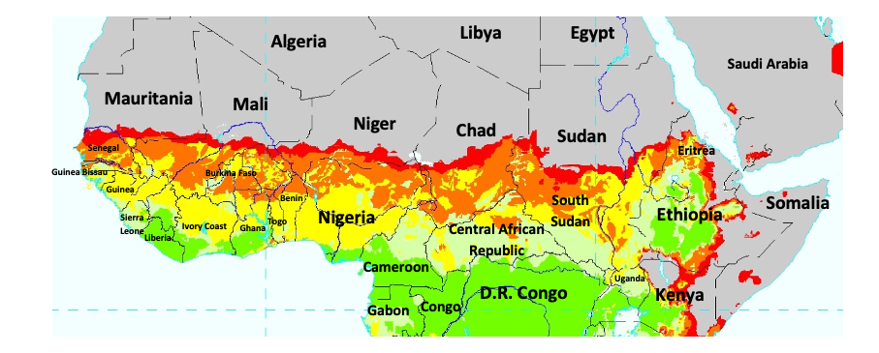
Write down the names of five countries at very high risk of desertification.

- ………………………………………
- ………………………………………
- ………………………………………
- ………………………………………
- ………………………………………

NATURAL AND HUMAN FACTORS
Complete the following table of natural and human factors behind desertification in Sudan.
Natural Factors | Human Factors

SHORT AND LONG-TERM EFFECTS
Complete the following table of short- and long-term effects of desertification in Sudan.
Short-Term Effects | Long-Term Effects

COLONIALISM IN SUDAN
Sudan was colonised by which two countries in 1899?
……………………………………. and …………………………………………………
Sudan gained independence from the British Empire in …………............ . South Sudan became independent from Sudan in ……………………

ASSESSING THE IMPACT OF EMPIRE on DESERTIFICATION
What difference, if any, did the British Empire make to the causes and effects of desertification in Sudan?
………………………………………………………………………………………………………………………….………………………………………………………………………………………………………………………….………………………………………………………………………………………………………………………….………………………………………………………………………………………………………………………….…………………………………………………………………………………………………………………………

AGRICULTURE IN COLONIAL SUDAN
Look at the following poster. It was made by the “Empire Marketing Board” in 1935 and displayed in London. The poster was designed to promote cotton grown in colonial Sudan to the British public.
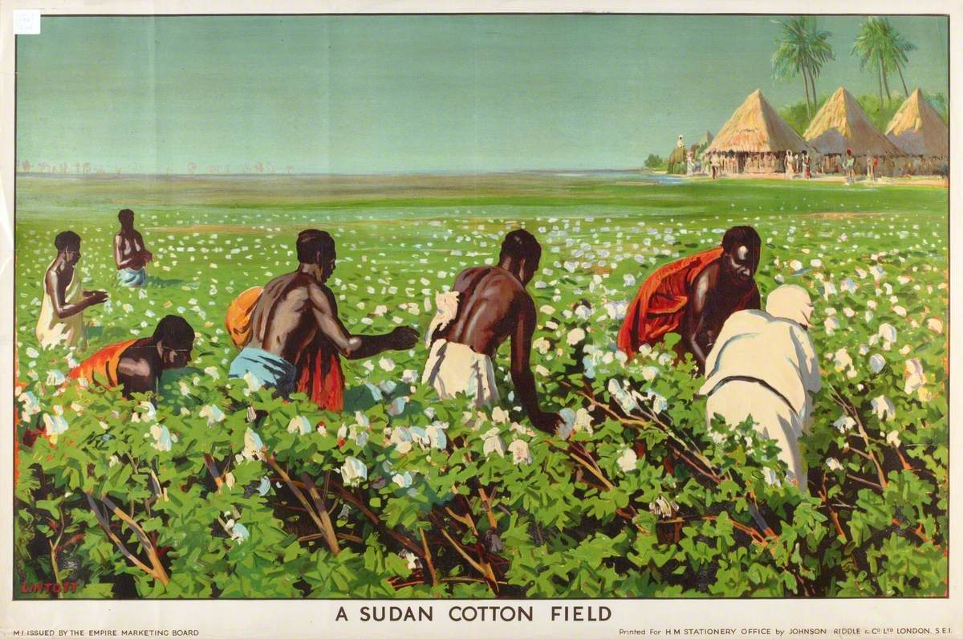
‘A Sudan Cotton Field’, Empire Marketing Board. Credit: Manchester Art Gallery, Art UK.

What aspects of colonialism are visible in the image?
……………………………..……………………………..……………………………..……………………………..……………………………..……………………………..……………………………..……………………………..……………………………..……………………………..……………………………..…………………………...……………………………..……………………………..……………………………..……………………………
How is the environment in Sudan shown in this image?
……………………………..……………………………..……………………………..……………………………..……………………………..……………………………..……………………………..……………………………..……………………………..……………………………..……………………………..…………………………..……………………………..……………………………..……………………………..…………………………….
Do you think this is an accurate image of colonial Sudan? Why? Why not?
……………………………..……………………………..……………………………..……………………………..……………………………..……………………………..……………………………..……………………………..……………………………..……………………………..……………………………..…………………………...……………………………..……………………………..……………………………..……………………………

STUDYING DESERTIFICATION IN POSTCOLONIAL SUDAN
Mohamed Hag Ali Hassan studied the physical forces behind desertification. He helped to create accurate models of the expansion of the desert.
How might this information help manage the risk of desertification in Sudan today?
……………………………..……………………………..……………………………..……………………………..……………………………..……………………………..……………………………..……………………………..……………………………..……………………………..……………………………..…………………………...……………………………..……………………………..……………………………..……………………………
Balgis Osman-Elasha studied the social and economic effects of desertification.
How might this information help manage the risk of desertification in Sudan today?
……………………………..……………………………..……………………………..……………………………..……………………………..……………………………..……………………………..……………………………..……………………………..……………………………..……………………………..…………………………..……………………………..……………………………..……………………………..…………………………….

