Tropical Rainforests
Case Study: Malaysia

THE EQUATOR
Look at this map of Malaysia. Draw a line representing the equator on it.
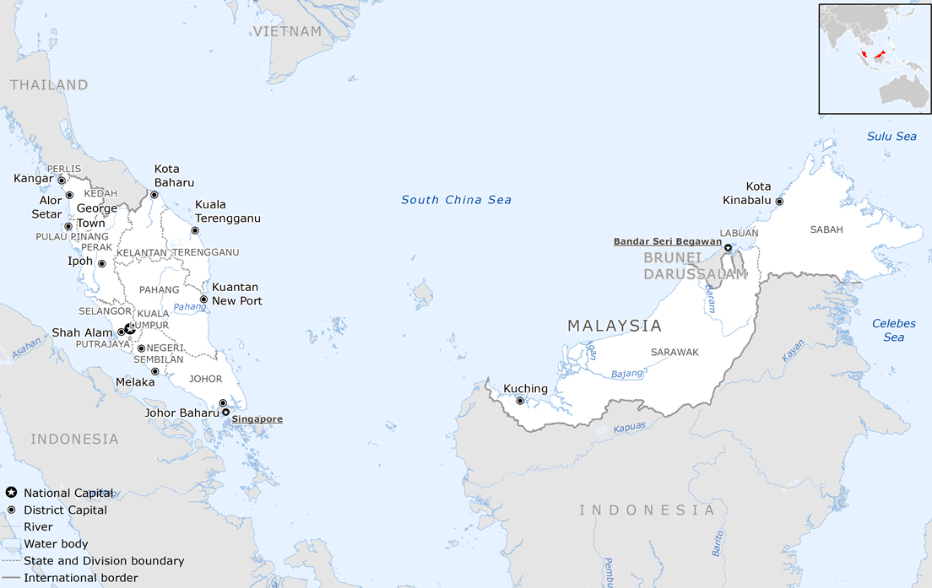
Political map of Malaysia. Credit: Wikimedia.
Why are tropical rainforests often found near the equator?
……………………………..……………………………..……………………………..…………………………………………………………..……………………………..……………………………..…………………………….……………………………..……………………………..……………………………..…………………………….

DEFORESTATION
Write down the definition of deforestation.
……………………………..……………………………..……………………………..……………………………..……………………………..……………………………..……………………………..……………………………..……………………………..……………………………..……………………………..………………………….

DEFORESTATION IN MALAYSIA
List three causes of deforestation:
- ……………………………..……………………………………………..………………
- ……………………………..……………………………………………..………………
- ……………………………..……………………………………………..………………
Circle the one you think is the main cause of deforestation in Malaysia.

IMPACT OF DEFORESTATION
Choose at least one of the following labels for each of the following impacts of deforestation: Economic, Cultural, Environmental
Impact | Type of Impact
Soil erosion leading to mudslides
Reduction in soil fertility
Loss of unique species of plants and animals
Loss of unique knowledge of the people who live in the rainforest

COLONIALISM IN MALAYSIA
Which major tropical cash crop did the British Empire introduce into Malaysia?
…………............…………............…………............…………............…………............
…………............…………............…………............…………............…………............

ASSESSING THE IMPACT OF EMPIRE on DEFORESTATION
What difference, if any, did the British Empire make to the causes and impacts of deforestation in Malaysia?
………………………………………………………………………………………………………………………….………………………………………………………………………………………………………………………….………………………………………………………………………………………………………………………….………………………………………………………………………………………………………………………….…………………………………………………………………………………………………………………………

PLANTATIONS IN COLONIAL MALAYSIA
Look at the following photographs of a rubber plantation. They were taken in 1910, when Malaysia was still part of the British Empire.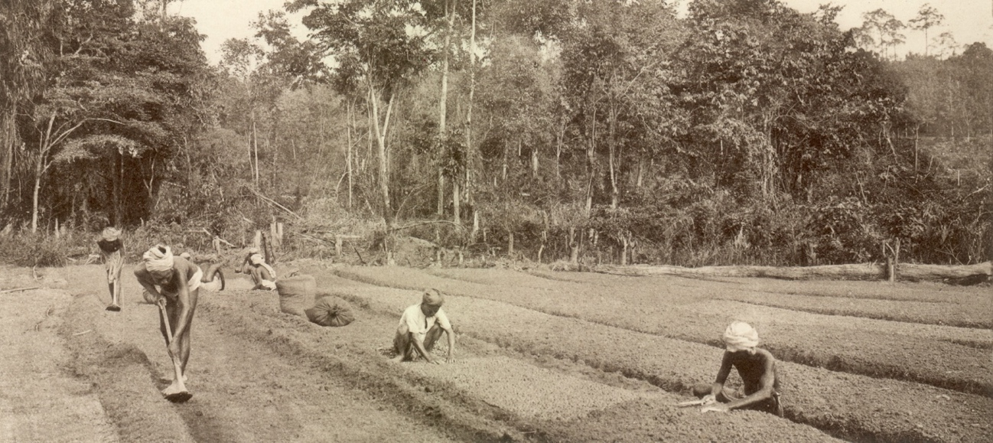
C.J. Kleingrothe “Sowing on a Rubber Plantation in Malaysia,” c.1910, Credit: Leiden University Library/ Wikimedia.
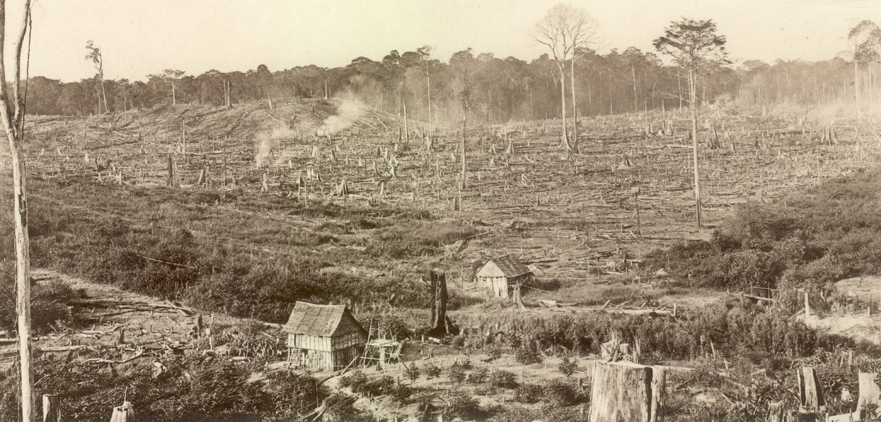
C.J. Kleingrothe “Reclaiming of forest for the benefit of a rubber plantation in Malaysia,” c.1910, Credit: Leiden University Library/Wikimedia.
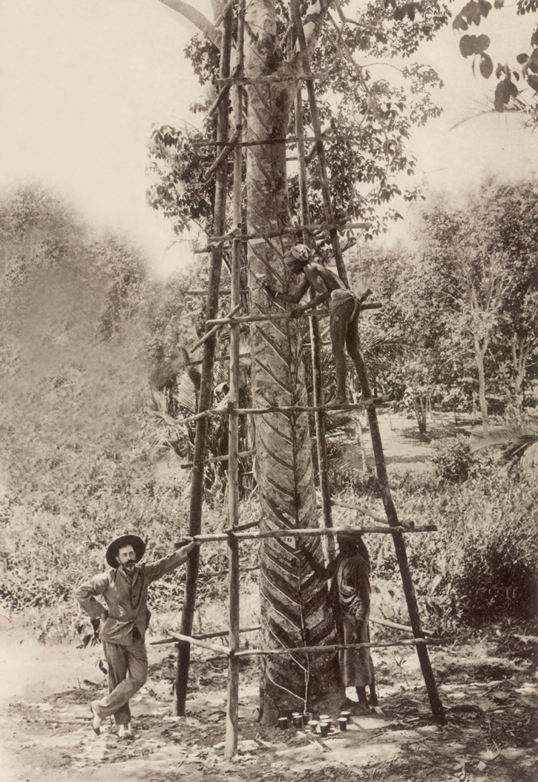
C.J. Kleingrothe “Tapping of a 23-year-old rubber tree on a plantation in Malaysia.,” c.1910, Credit: Leiden University Library/ Wikimedia.

What aspects of colonialism are visible in the photographs?
……………………………..……………………………..……………………………..……………………………..……………………………..……………………………..……………………………..……………………………..……………………………..……………………………..……………………………..…………………………...……………………………..……………………………..……………………………..……………………………
What evidence of deforestation are there in the photographs?
……………………………..……………………………..……………………………..……………………………..……………………………..……………………………..……………………………..……………………………..……………………………..……………………………..……………………………..…………………………..……………………………..……………………………..……………………………..…………………………….

CONSERVATION OF TROPICAL RAINFORESTS IN POSTCOLONIAL MALAYSIA
Lim Boo Liat helped establish the National Zoo of Malaysia in 1963.
What role do zoos play in the conservation of tropical rainforests?
……………………………..……………………………..……………………………..……………………………..……………………………..……………………………..……………………………..……………………………..……………………………..……………………………..……………………………..…………………………...……………………………..……………………………..……………………………..……………………………
Salleh Mohd Nor helped establish national parks in Malaysia.
What role do national parks play in the conservation of tropical rainforests?
……………………………..……………………………..……………………………..……………………………..……………………………..……………………………..……………………………..……………………………..……………………………..……………………………..……………………………..…………………………..……………………………..……………………………..……………………………..…………………………….

MAPPING DEFORESTATION
Examine the following tables of data collected by Global Forest Watch. You can examine the full data set on the following website: https://www.globalforestwatch.org/dashboards/country/MYS/
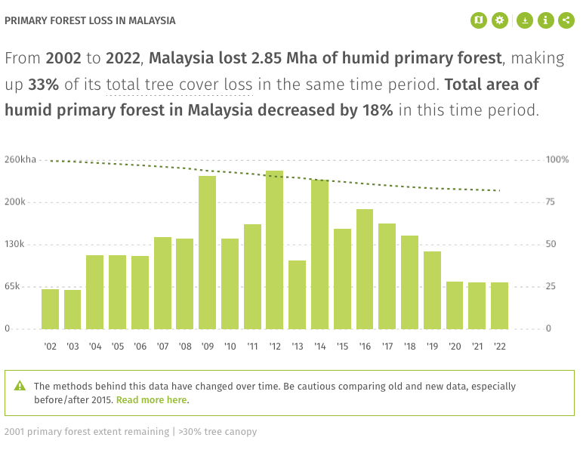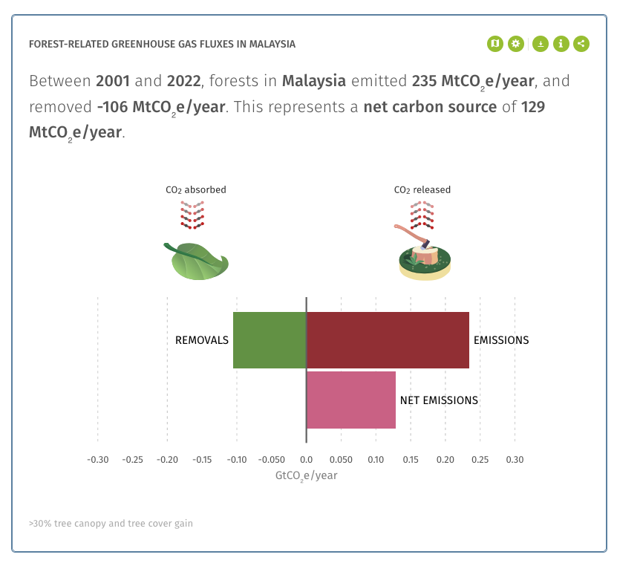

What role do rainforests play in the carbon cycle?
……………………………..……………………………..……………………………..……………………………..……………………………..……………………………..……………………………..……………………………..……………………………..……………………………..……………………………..…………………………..……………………………..……………………………..……………………………..…………………………….
Explain why there is a ‘net emission’ of 129 Mt (metric tons) of CO₂ per year from Malaysia’s forest regions.
……………………………..……………………………..……………………………..……………………………..……………………………..……………………………..……………………………..……………………………..……………………………..……………………………..……………………………..…………………………..……………………………..……………………………..……………………………..…………………………….

