Cold Environments
Case Study: Arctic

The ARCTIC
Examine the following map. Identify the dashed line marking the Arctic Circle.
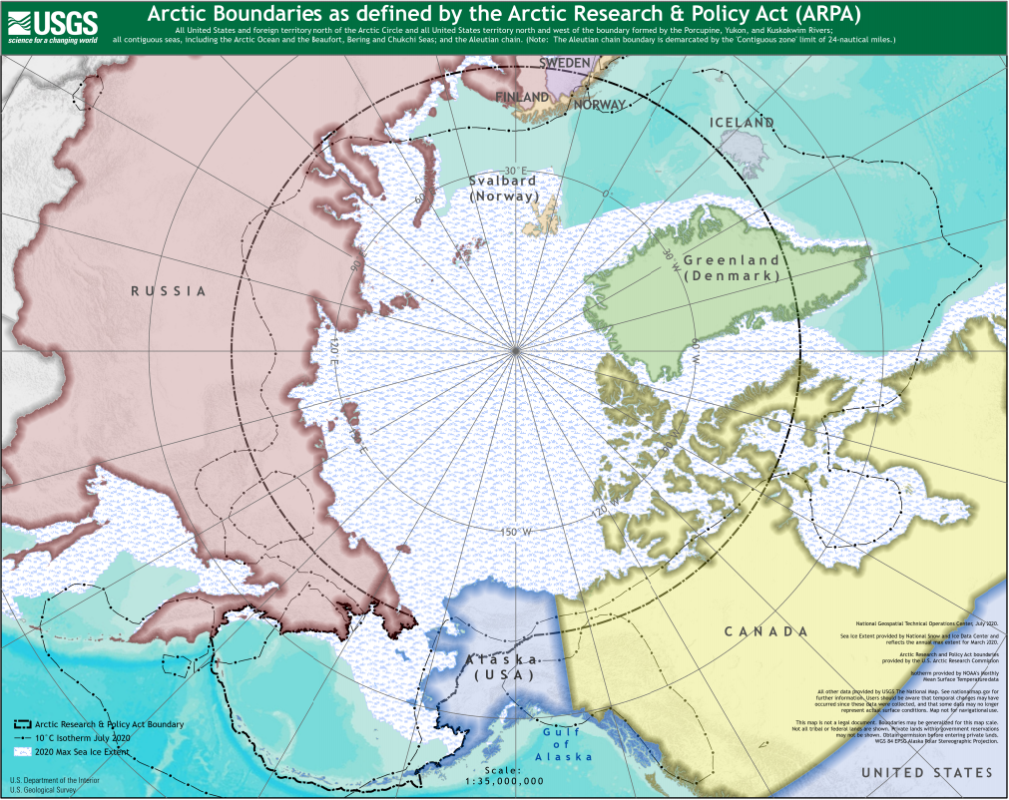
Map of Arctic Circle. Credit: United States Geological Survey/Public Domain.
Write down the names of the eight countries which have territory within the Arctic Circle:

- ………………………………………
- ………………………………………
- ………………………………………
- ………………………………………
- ………………………………………
- ………………………………………
- ………………………………………
- ………………………………………

INDIGENOUS PEOPLE IN THE ARCTIC
Write down the definition of Indigenous people.
……………………………..……………………………..……………………………..……………………………..……………………………..……………………………..……………………………..……………………………..……………………………..……………………………..……………………………..………………………….
Give example of three different Indigenous groups who live in the Arctic.
- ……………………………..………
- ……………………………..………
- ……………………………..………

COLONIALISM AND RESOURCES IN THE ARCTIC
European countries began to colonise the Arctic from around 1600 onwards.
Write down five natural resources that European countries took from the Arctic.
- ……………………………..………
- ……………………………..………
- ……………………………..………
- ……………………………..………
- ……………………………..………

THE NORTHWEST PASSAGE
The Northwest Passage is a sea route connecting the Atlantic and Pacific Oceans across the Arctic.
Draw a line to show the route of the Northwest Passage on the map below.
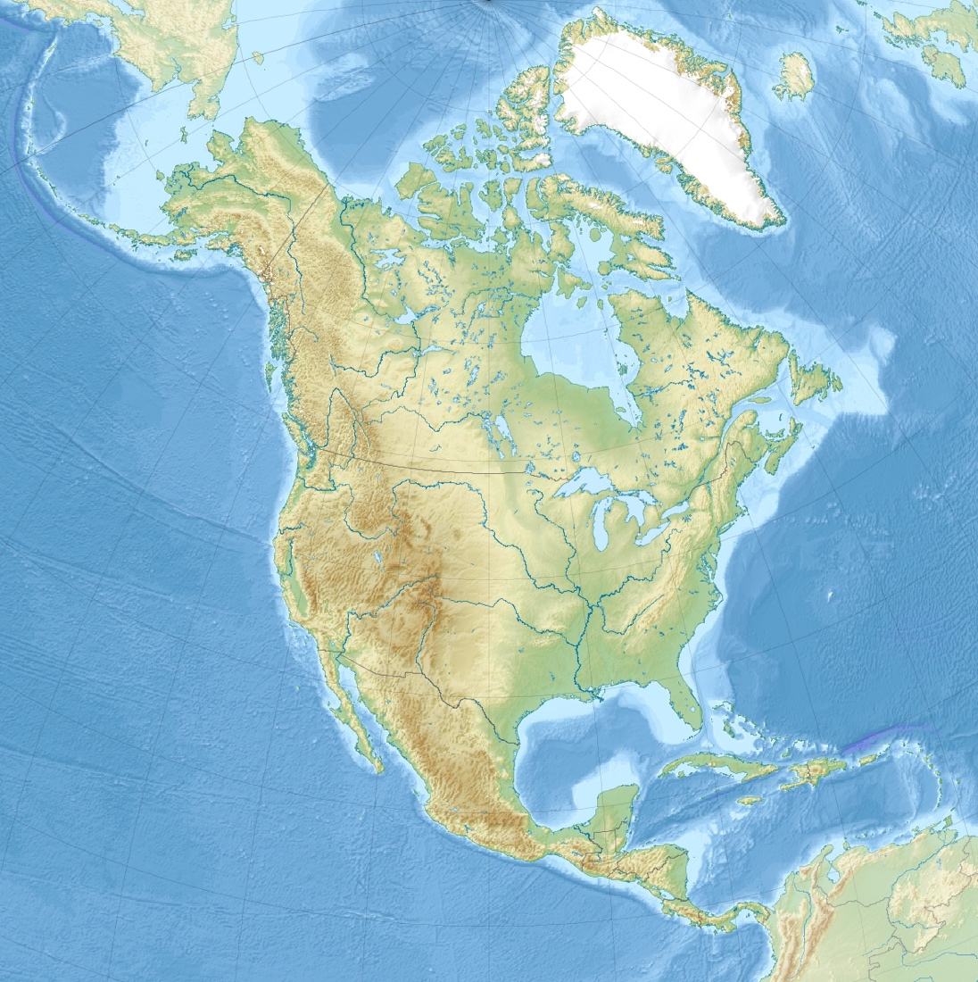
Atlantic Ocean
Pacific Ocean
Topographic map of North America. Credit: Wikimedia.
Why did European countries want to find the Northwest Passage?
………………………………………………………………………………………………………………………….………………………………………………………………………………………………………………………….………………………………………………………………………………………………………………………….

RISKS OF ECONOMIC DEVELOPMENT
What are the risks posed by increased economic development in the Arctic?
………………………………………………………………………………………………………………………….………………………………………………………………………………………………………………………….………………………………………………………………………………………………………………………….………………………………………………………………………………………………………………………….
In what ways is this similar or different from colonialism?
………………………………………………………………………………………………………………………….………………………………………………………………………………………………………………………….………………………………………………………………………………………………………………………….………………………………………………………………………………………………………………………….

INDIGENOUS KNOWLEDGE AND STRATEGIES
Indigenous people have knowledge of the Arctic environment as well as strategies for responding to climate change and economic development.
Fill in the table below with examples of Indigenous knowledge and strategies.
Knowledge | Strategies

INUIT CLIMATE POLICY
Examine the following extract from the Inuit Climate Change Strategy policy document produced by the Inuit Tapiriit Kanatami. To read the full document, see the Inuit Tapiriit Kanatami website.
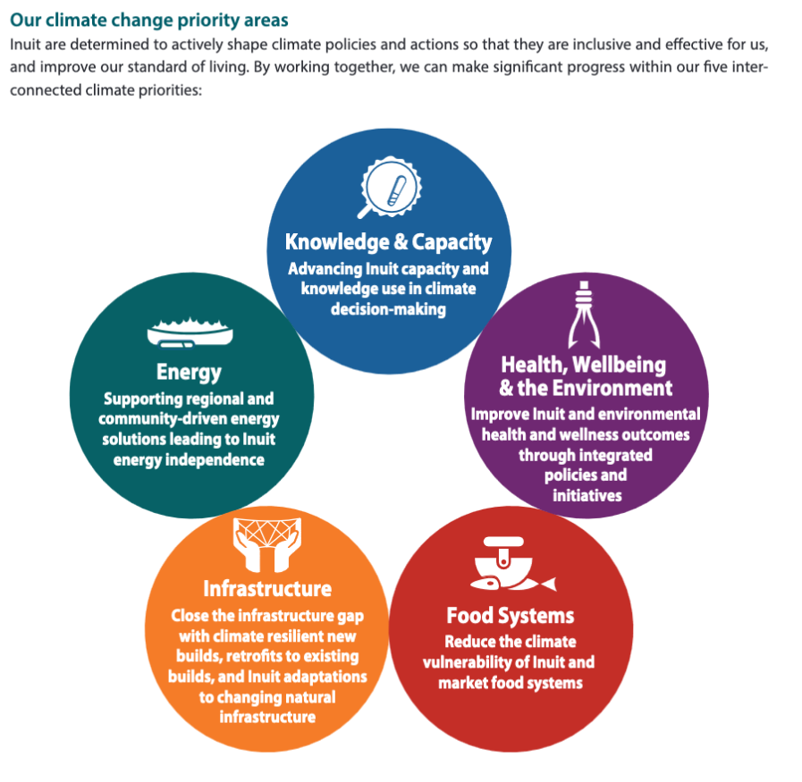

For each of the five priority areas, suggest a practical action which might help achieve that goal.

1. Knowledge and Capacity
………………………………………………………………………………………………………………………….………………………………………………………………………………………………………………………….………………………………………………………………………………………………………………………….
2. Health, Wellbeing and the Environment
………………………………………………………………………………………………………………………….………………………………………………………………………………………………………………………….………………………………………………………………………………………………………………………….
3. Food Systems
………………………………………………………………………………………………………………………….………………………………………………………………………………………………………………………….………………………………………………………………………………………………………………………….
4. Infrastructure
………………………………………………………………………………………………………………………….………………………………………………………………………………………………………………………….………………………………………………………………………………………………………………………….
5. Energy
………………………………………………………………………………………………………………………….………………………………………………………………………………………………………………………….………………………………………………………………………………………………………………………….

